K-5 STEM in Science Classrooms
What is the difference between Science and Engineering?
Generally, Science is the study of the physical world, while Engineering applies scientific knowledge to design processes, structures or equipment. Both Engineers and Scientists will have a strong knowledge of science, mathematics and technology, but Engineering students will learn to apply these principles to designing creative solutions to Engineering challenges.
So when we think of a scientist versus engineer, the two aren’t separate entities but belong to each other – without science, there wouldn’t be engineering.
What is the difference between Science and Technology?
The terms science and technology, are often pronounced in the same breath and used as synonyms, because they are closely intertwined, that their difference is often times ignored. Science is all about acquiring knowledge of the natural phenomenon along with the reasons for such phenomenon, like Why the sky is blue? Why are leaves green? Why rainfall occurs? What are the colors of the rainbow? How do plants make their food? And so forth. When this knowledge is put to practice, to solve human needs or problems, it is termed as technology.
So, in short, science deals with theories, principles and laws whereas technology is all about products, processes and designs.
What is the difference between Science, Engineering and Technology?
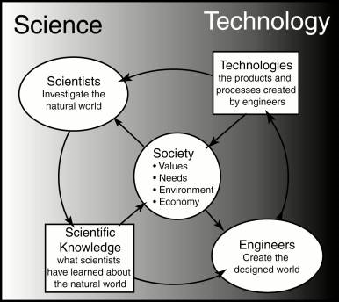 | 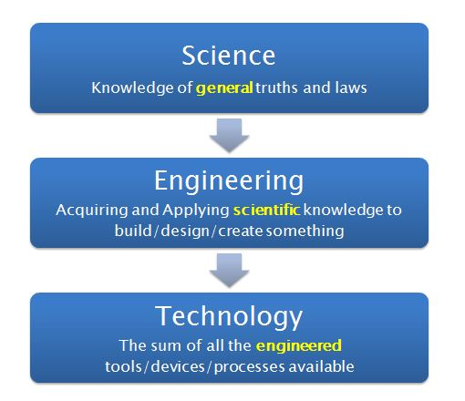

The new Georgia Standards of Excellence (GSE) have been written with the Science & Engineering Practices (SEP) embedded within the standard. The expectation is that instruction involves the deliberate and continuous integration of the 8 SEPs. The standards below highlight the grade levels, standards and elements where technology, math and engineering practices are specifically addressed.

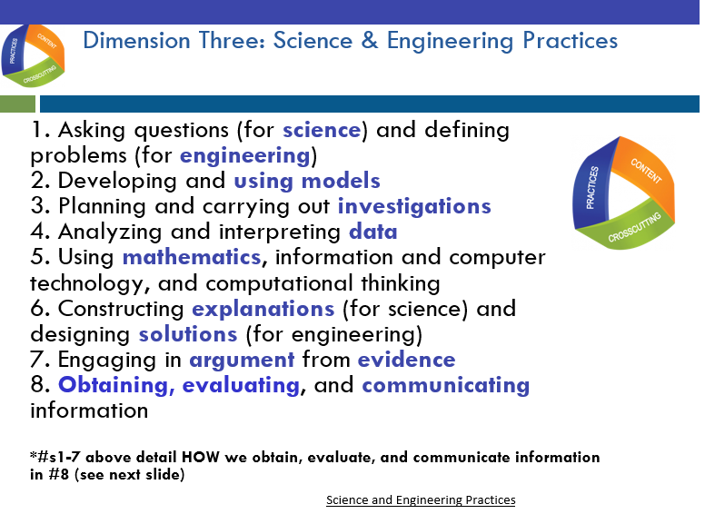

GSE Standard Alignment to STEM (Math, Technology, Engineering)
Kindergarten:
Standard | Element
SKE2 (Earth and Space Science) | Obtain, evaluate, and communicate information to describe the physical attributes of earth materials (soil, rocks, water, and air).
 | c. Use tools to observe and record physical attributes of soil such as texture and color. | Technology
SKP1 (Physical Science) | Obtain, evaluate, and communicate information to describe objects in terms of the materials they are made of and their physical attributes.
 | b. Use senses and science tools to classify common objects, such as buttons or swatches of cloth, according to their physical attributes (color, size, shape, weight, and texture). | Technology
SKP2 (Physical Science) | Obtain, evaluate, and communicate information to compare and describe different types of motion.
 | b. Construct an argument as to the best way to move an object based on its physical attributes. | Engineering
First Grade:
Standard | Element
S1E1 (Earth and Space Science) | Obtain, evaluate, and communicate weather data to identify weather patterns.
 | a. Represent data in tables and/or graphs to identify and describe different types of weather and the characteristics of each type. | Math
 | c. Plan and carry out investigations on current weather conditions by observing, measuring with simple weather instruments (thermometer, wind vane, rain gauge), and recording weather data (temperature, precipitation, sky conditions, and weather events) in a periodic journal, on a calendar, and graphically. | Technology  Math
 | d. Analyze data to identify seasonal patterns of change.  (Clarification statement: Examples could include temperature, rainfall/snowfall, and changes to the environment.) | Math
S1P1 (Physical Science) | Obtain, evaluate, and communicate information to investigate light and sound.
 | e. Design a signal that can serve as an emergency alert using light and/or sound to communicate over a distance. | Engineering  Technology
S1P2 (Physical Science) | Obtain, evaluate, and communicate information to demonstrate the effects of magnets on other magnets and other objects.
 | b. Plan and carry out an investigation to demonstrate how magnets attract and repel each other and the effect of magnets on common objects. | Technology
S1L1  (Life Science) | Obtain, evaluate, and communicate information about the basic needs of plants and animals.
 | c. Design a solution to ensure that a plant or animal has all of its needs met. | Engineering
Second Grade:
Standard | Element
S2E2 (Earth and Space Science) | Obtain, evaluate, and communicate information to develop an understanding of the patterns of the sun and the moon and the sun’s effect on Earth.
 | b. Design and build a structure that demonstrates how shadows change throughout the day. | Engineering
 | c. Represent data in tables and/or graphs of the length of the day and night to recognize the change in seasons. | Math
S2P2 (Physical Science) | Obtain, evaluate, and communicate information to explain the effect of a force (a push or a pull) in the movement of an object (changes in speed and direction).
 | b. Design a device to change the speed or direction of an object. | Engineering
 | c. Record and analyze data to decide if a design solution works as intended to change the speed or direction of an object with a force (a push or a pull). | Engineering  Math
S2L1  (Life Science) | Obtain, evaluate, and communicate information about the life cycles of different living organisms.
 | b. Plan and carry out an investigation of the life cycle of a plant by growing a plant from a seed and by recording changes over a period of time. | Math
Third Grade:
Standard | Element
S3P1 (Physical Science) | Obtain, evaluate, and communicate information about the ways heat energy is transferred and measured.
 | b. Plan and carry out an investigation to gather data using thermometers to produce tables and charts that illustrate the effect of sunlight on various objects.  (Clarification statement: The use of both Fahrenheit and Celsius temperature scales is expected.) | Technology  Math
 | c. Use tools and every day materials to design and construct a device/structure that will increase/decrease the warming effects of sunlight on various materials.  (Clarification statement: Conduction, convection, and radiation are taught in upper grades.) | Engineering  Technology
S3L2  (Life Science) | Obtain, evaluate, and communicate information about the effects of pollution (air, land, and water) and humans on the environment.
 | b. Explore, research, and communicate solutions, such as conservation of resources and recycling of materials, to protect plants and animals. | Engineering
Fourth Grade:
Standard | Element
S4P1  (Physical Science) | Obtain, evaluate, and communicate information about the nature of light and how light interacts with objects.
 | b. Plan and carry out investigations to describe the path light travels from a light source to a mirror and how it is reflected by the mirror using different angles. | Technology
 | c. Plan and carry out an investigation utilizing everyday materials to explore examples of when light is refracted.  (Clarification statement: Everyday materials could include prisms, eyeglasses, and a glass of water.) | Technology
S4P2  (Physical Science) | Obtain, evaluate, and communicate information about how sound is produced and changed and how sound and/or light can be used to communicate.
 | a. Plan and carry out an investigation utilizing everyday objects to produce sound and predict the effects of changing the strength or speed of vibrations. | Technology
 | b. Design and construct a device to communicate across a distance using light and/or sound. | Engineering  Technology
S4P3  (Physical Science) | Obtain, evaluate, and communicate information about the relationship between balanced and unbalanced forces.
 | c. Ask questions to identify and explain the uses of simple machines (lever, pulley, wedge, inclined plane, wheel and axle, and screw) and how forces are changed when simple machines are used to complete tasks.  (Clarification statement: The use of mathematical formulas is not expected.) | Technology
S4L1  (Life Science) | Obtain, evaluate, and communicate information about the roles of organisms and the flow of energy within an ecosystem.
 | d. Use printed and digital data to develop a model illustrating and describing changes to the flow of energy | Technology
Fifth Grade:
Standard | Element
S5E1  (Earth and Space Science) | Obtain, evaluate, and communicate information to identify surface features on the Earth caused by constructive and/or destructive processes.
 | c. Ask questions to obtain information on how technology is used to limit and/or predict the impact of constructive and destructive processes.  (Clarification statement: Examples could include seismological studies, flood forecasting (GIS maps), engineering/construction methods and materials, and infrared/satellite imagery.) | Technology
S5P2  (Physical Science) | Obtain, evaluate, and communicate information to investigate electricity.
 | b. Design a complete, simple electric circuit, and explain all necessary components. | Engineering  Technology
S5P3  (Physical Science) | Obtain, evaluate, and communicate information about magnetism and its relationship to electricity.
S5L3  (Life Science) | Obtain, evaluate, and communicate information to compare and contrast the parts of plant and animal cells.
 | a. Gather evidence by utilizing technology tools to support a claim that plants and animals are comprised of cells too small to be seen without magnification. | Technology

