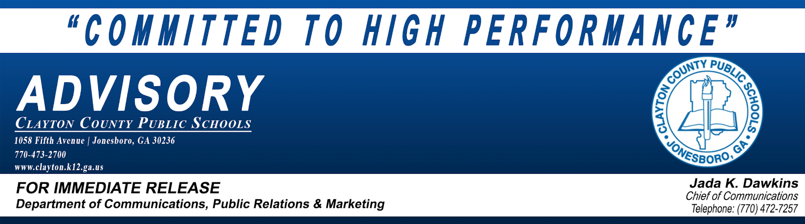
July 9, 2018
Superintendent of Schools to Meet With
Support Staff, Secretaries, Etc. on Tuesday, July 17, 2018

Clayton County Public Schools (CCPS) Superintendent of Schools, Dr. Morcease J. Beasley, will host a meeting with Support Staff, secretaries, etc. on Tuesday, July 17th, at the CCPS Performing Arts Center. The Performing Arts Center is located at 2530 Mt. Zion Parkway in Jonesboro, Georgia. The meeting is scheduled from 1:00 p.m. until 2:30 p.m.
MEETING | DATE | TIME | LOCATION
Superintendent’s Meeting with Support Staff, Secretaries, Etc. | Tuesday, July 17, 2018 | 1:00 p.m. – 2:30 p.m. | CCPS Performing Arts Center  2530 Mt. Zion Pkwy, Jonesboro, GA

About Clayton County Public Schools
Clayton County Public Schools (CCPS) is fully accredited through AdvancED – Southern Association of Colleges and Schools Council on Accreditation and School Improvement. The district offers a focused world class program based on a challenging curriculum which is taught from pre-kindergarten through 12th grade. Serving almost 55,000 students, Clayton County Public Schools is ranked among the 100 largest school districts in the U.S., and is the fifth largest school system in Georgia.
###

