Bio of Rev. Mark Anthony Christmas, Sr.

Rev. Mark A. Christmas was born to the parents of Isaac and Beverly Christmas in New Orleans, Louisiana. At an early age, Rev. Christmas and his family moved to Saginaw, Michigan where he was educated in the public school system. In 1991, he relocated to Atlanta, Georgia. Rev. Christmas received a Bachelor’s of Science degree in Business Management from Shorter College and completed a Masters of Divinity degree from the Interdenominational Theological Center in 2013.

Rev. Christmas is humble servant for God being obedient to the ministry. His experience in the Clayton County Public School system as a Parent Liaison, Graduation Coach and Safe and Drug Awareness Coordinator has made him valuable to the community as well. He currently serves as a school board member for Clayton County School District Two with the best interest of the students paramount in his service.

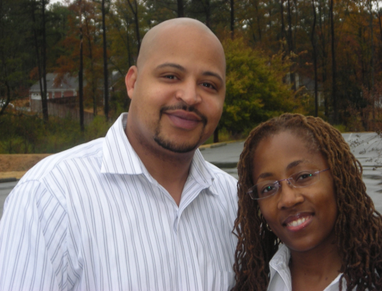
He is married to the lovely Betrice Christmas, passionately known as Lady B. They have two sons, Sherwin and Mark Jr., and three grandchildren.
Pastor Mark & Lady B. Christmas
Pastor Mark & Lady B. Christmas
Pastor Mark & Lady B. Christmas
Pastor Mark & Lady B. Christmas

