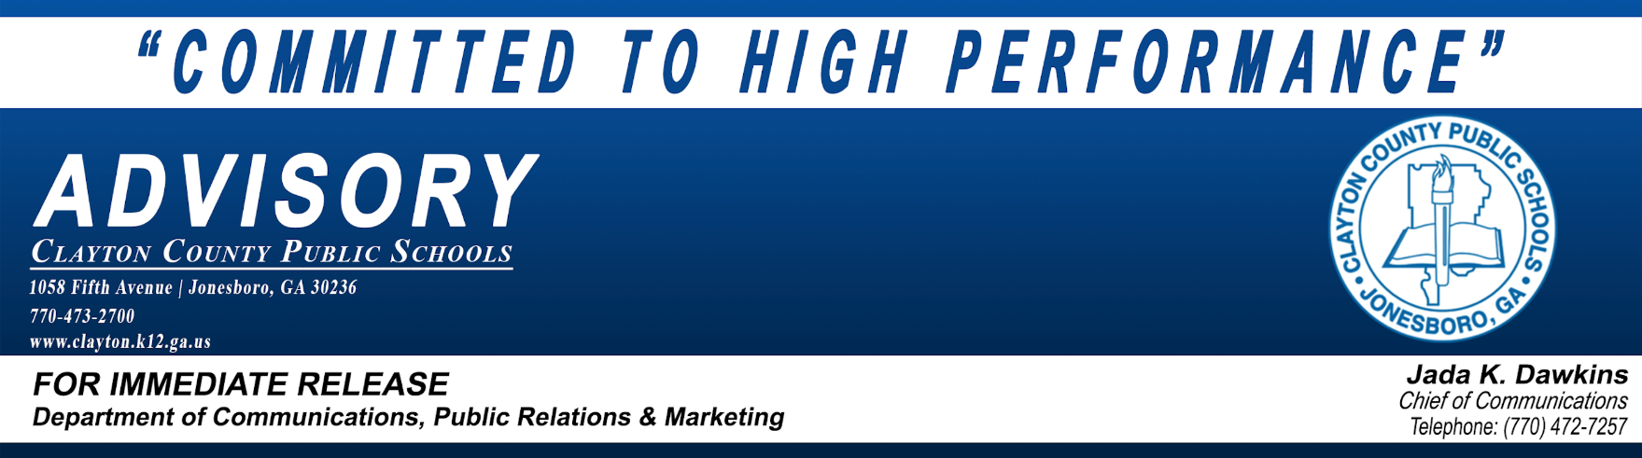
June 24, 2020

CCPS Class of 2020 Virtual Graduations Set for June 25-27
Traditional ceremonies expected to be scheduled for late summer or early fall

JONESBORO – A celebration of the Clayton County Public Schools (CCPS) Class of 2020, in alignment with COVID-19 guidelines/restrictions, will take place on Thursday through Saturday, June 25-27, 2020 with the presentation of a Virtual Graduation Ceremony for each of the district’s high schools. The virtual programs will feature photos and video messages contributed by members of each school’s Class of 2020.

To view or access the virtual graduations, please click the following link: https://www.clayton.k12.ga.us/cms/One.aspx?portalId=54515&pageId=23749746 or by going to each high school's website. The link should be available at least one day prior to each school’s virtual graduation.

The virtual graduation programs will premier utilizing the following schedule outlined below.

Thursday, June 25 | Friday, June 26 | Saturday, June 27
10 am - Lovejoy HS | 10 am - Jonesboro HS | 10 am - Drew HS
1 pm - Mundy’s Mill HS | 1 pm - Mt. Zion HS | 1 pm - North Clayton HS
4 pm - Morrow HS | 4 pm - Elite Scholars Academy | 4 pm - Riverdale HS
7 p.m. - Forest Park HS | 7 pm - Stilwell SOA | 7 pm - Perry Career Academy

Having trouble accessing the streamed virtual graduation? Please review the following support:
- Please ensure that your device's operating system is up to date (this includes mobile devices)
- Please use one of the following recommended internet browsers: Chrome, Firefox, Safari
- Please ensure that your browser is up to date and refresh as necessary
Traditional Ceremony
The planning efforts to provide a traditional graduation ceremony for the Class of 2020 have been greatly impacted by the COVID-19 Pandemic. Initial scheduling of ceremonies for June 25-26, 2020, to be held in the district’s stadiums, had to be postponed. This action was prompted by the May 28, 2020, announcement to extend the State of Emergency to July 12, 2020, by Georgia Governor Brian Kemp. At that time, the governor announced the adjustment of the limit on group gatherings, from ten to 25 individuals. That number has since been adjusted to 50, keeping all existing social distancing guidelines in place.

In an effort to comply with the State of Emergency, maximum group size limitations, and social distancing guidelines currently in place, district leadership has decided to postpone a traditional ceremony for the Class of 2020 to late summer or early fall. It is hoped that existing pandemic conditions as they relate to large group events will be more favorable. Details on the traditional ceremonies will be released as they become available.

About Clayton County Public Schools
Clayton County Public Schools (CCPS) is fully accredited by AdvancED – Southern Association of Colleges and Schools Council on Accreditation and School Improvement. The district offers a focused world-class program based on a challenging curriculum which is taught from pre-kindergarten through 12th grade. Serving over 55,000 students, Clayton County Public Schools is ranked among the 100 largest school districts in the U.S. and is the fifth-largest school system in Georgia.
###

