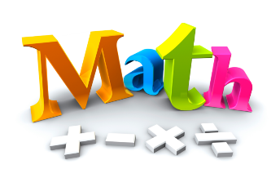
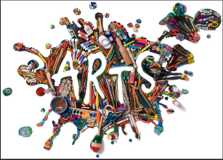
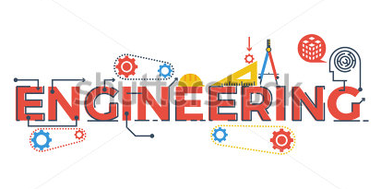
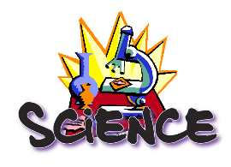

What is STEAM?

STEAM is an educational approach to learning that uses Science, Technology, Engineering, the Arts and Mathematics as access points for guiding student inquiring, dialogue, and critical thinking. The end results are students who take thoughtful risks, engage in experiential learning, persist in problem-solving, embrace collaboration, and work through the creative process. These are the innovators, educators, leaders, and learners of the 21st century! ~Education Closet

The Need for STEAM
Students who have high levels of art participation show higher levels of academic achievement, classroom engagment and community participation. They also develop soft skills such as creativity, collaboration and risk-taking, which are just as important in today’s workforce.

Vidcode states, “Art education allows students to learn things in a more open-ended way and make them applicable to real life. Arts and creativity are crucial to the sciences, technology and computer science. They are the tool that allows technology in real life!” Vidcode further states, “Arts are used in websites and user interfaces design, advertising, product design and usability, branding and start-up creation among countless other uses, all things are curitl to STEM learning and careers.”

Arts Integration vs. STEAM
ARTS INTEGRATION: Connects the arts and at least one other area of study with aligning an assessed standard.

STEAM: Uses design principals and processes from the arts to mainpulate science, technology, engineering, and mathematics (arts act as a catalyst for STEM); STEM and arts integration combined.

Arts integration and STEAM are approaches to learning. They are not curriculum, nor are these a set of strategies. Instead, these are research-based shifts which embed both the art and the science of teaching and learning.

Example Geometry and the Arts Curriculum Map:

Math Standard: Classify two-dimensional figures into categories based on their properties.

Art Standard: Intepret art by analyzing charateristics of form and structure, contextual information, subject matter, visual elements, and use of media to identify ideas and modd conveyed.

Artistic Process: Responding
Anchor standard: Interpret intent and meaning in artistic work.

Lesson Idea: Using the work of Kandinsky, measure a variety of shapes he used in his work. Compare all of the atttributes and draw conclusions about 2D figures in each subcategory represented in the work. Then, create a piece of artwork in the sytel of Kandinsky that maintains these distinct attributes and label each area of the artwork with the attributes assigned.

